Day 10

VALIDATE LEADER ELEMENTS:
CODE:
import java.util.*;
import java.util.Collections;
public class leader{
public static void main (String[] args) {
Scanner sc=new Scanner(System.in);
System.out.print("N: ");
int n=sc.nextInt();
System.out.print("Enter the Elements: ");
int arr[]=new int[n];
for(int i=0;i<n;i++){
arr[i]=sc.nextInt();
}
int max=arr[n-1];
ArrayList<Integer> list=new ArrayList<>();
list.add(max);
for(int i=n-2;i>=0;i--){
if(arr[i]>=max){
max=arr[i];
list.add(max);
}
}
Collections.reverse(list);
System.out.print("Leader Elements: ");
for(int l:list){
System.out.print(l+" ");
}
}
}
OUTPUT:
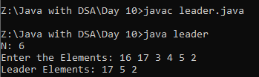
REVERSE THE LAST DIGIT:
CODE:
import java.util.*;
public class reverse{
public static void main (String[] args) {
Scanner sc=new Scanner(System.in);
System.out.print("N: ");
int n=sc.nextInt();
System.out.print("Enter the Elements: ");
int arr[]=new int[n];
for(int i=0;i<n;i++){
arr[i]=sc.nextInt();
}
System.out.print("K: ");
int k=sc.nextInt();
int a=n-k;
ArrayDeque<Integer> q=new ArrayDeque<>();
for(int i=a-1;i>=0;i--){
q.addFirst(arr[i]);
}
for(int i=n-1;i>=a;i--){
q.addLast(arr[i]);
}
System.out.print(q);
}
}
OUTPUT:
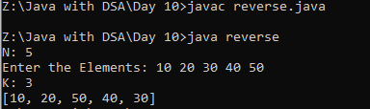
REVERSE THE LAST DIGIT USING STACK:
CODE:
import java.util.*;
public class sta{
public static void main (String[] args) {
Scanner sc=new Scanner(System.in);
System.out.print("N: ");
int n=sc.nextInt();
System.out.print("Enter the Elements: ");
int arr[]=new int[n];
for(int i=0;i<n;i++){
arr[i]=sc.nextInt();
}
System.out.print("K: ");
int k=sc.nextInt();
ArrayDeque<Integer> q=new ArrayDeque<>();
Stack<Integer> stack=new Stack<>();
for(int i=0;i<n-k;i++){
q.addLast(arr[i]);
}
for(int i=n-k;i<n;i++){
stack.push(arr[i]);
}
while(!stack.isEmpty()){
q.addLast(stack.pop());
}
while(!q.isEmpty()){
System.out.print(q.pollFirst() + " ");
}
}
}
OUTPUT:
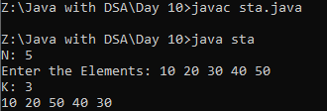
PRINT THE WORD WITHOUT REPEATING CHARACTER:
CODE:
import java.util.*;
public class word{
public static void main (String[] args) {
Scanner sc=new Scanner(System.in);
System.out.print("Input String: ");
String str=sc.nextLine();
Set<Character> set=new LinkedHashSet<>();
for(int i=0;i<str.length();i++){
set.add(str.charAt(i));
}
System.out.print(set);
}
}
OUTPUT:
